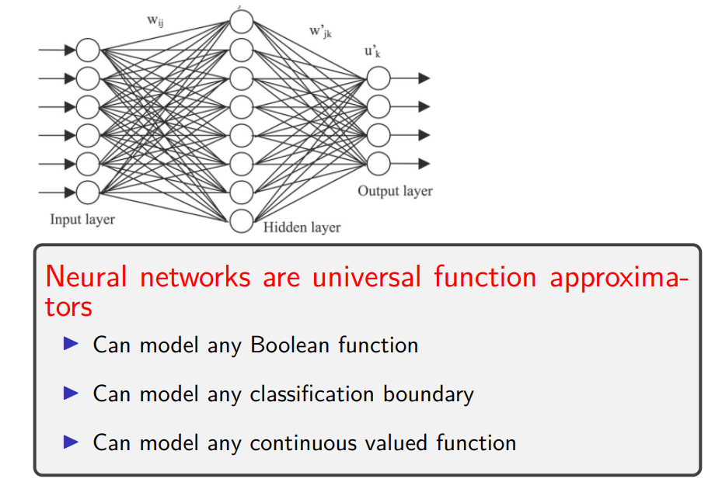

hidden layers: we know the input and desired output

the values the neurons take inn the hidden layers are not visible

question: since neural networks are universal approximators any network of any architecture can approximate any function to arbitrary precision. FALSE

any network: a single perceptron can not model the pentagon shape.

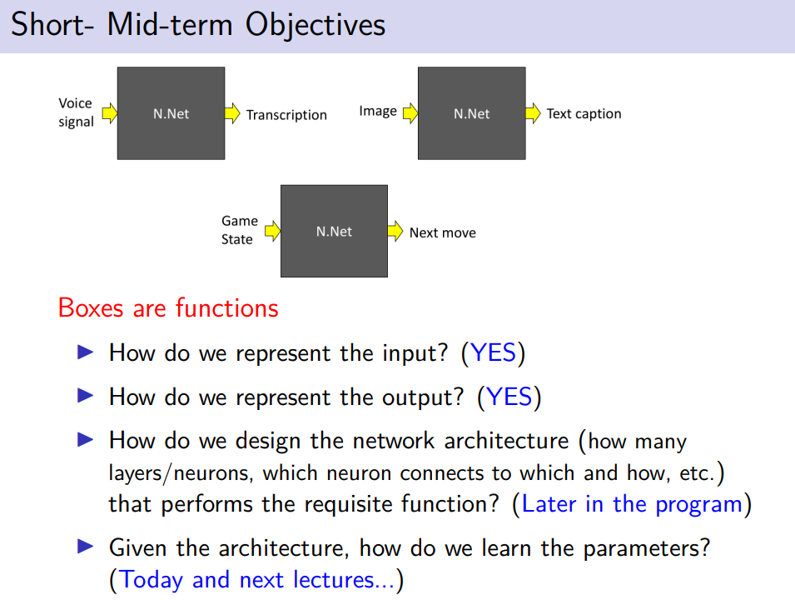

we have problems, find possible moves to go to a next stage (game theory problems)

we have a corresponding desired outcome and the logic (aka neural network)

NN it is a function, from input to output

Inout can be
- binary
- rear

output can be
- binary
- vector (multiple neurons)
- binary vector
- rear output

which is the best way to design the network architecture in ordered to approximate our requisite function? how to connect layers, how many layers… many possibilities

suppose we find our archictureture and we can confident we can approximate it, how do we know the parameters

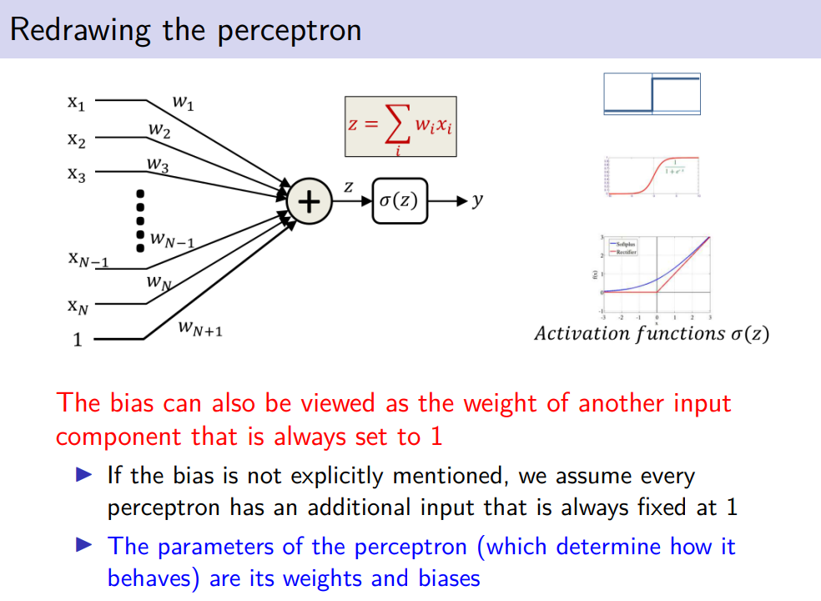

it is possible to transform the bias we can consider the bias as an additional input
W_{n+1} is weight of bias

z is the hyperplane separating without the bias

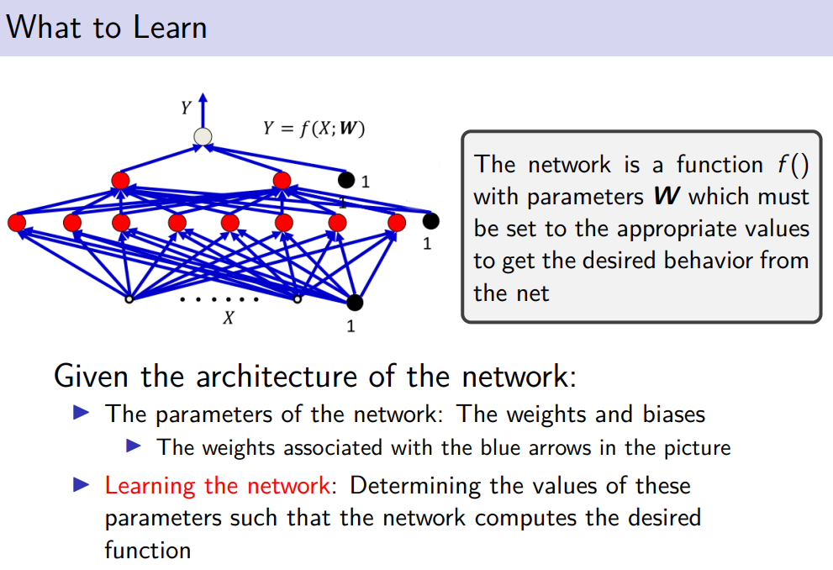

given the input x we can see our network as a function f as an input but also this function depends on the parameter W to learn.

aim: learn the values of the connectio so that the desired output Y is as close as possible to the output of our network. We want to find W so that Y and X are close as pssibile

F is a function of X (the input) but F is a paramenteric function that depends on W, different W provides different output

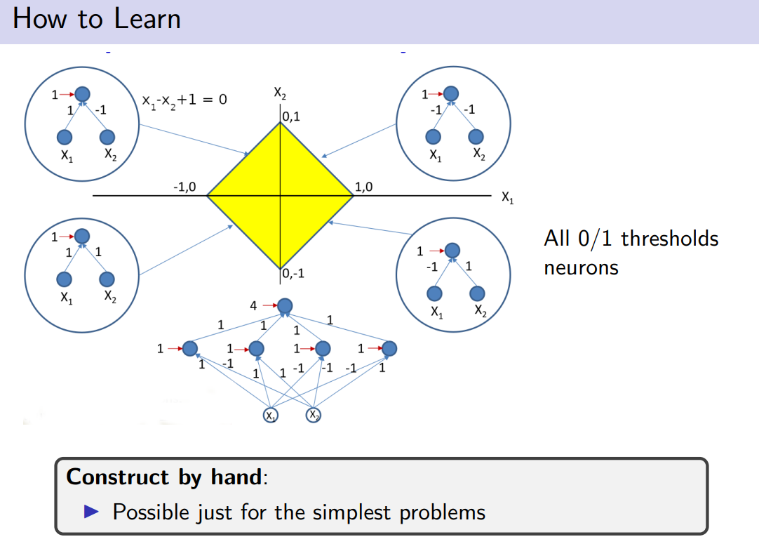

this multiplayer peceptron recognise the yellow region.

consider y as x₂ and x = x₁

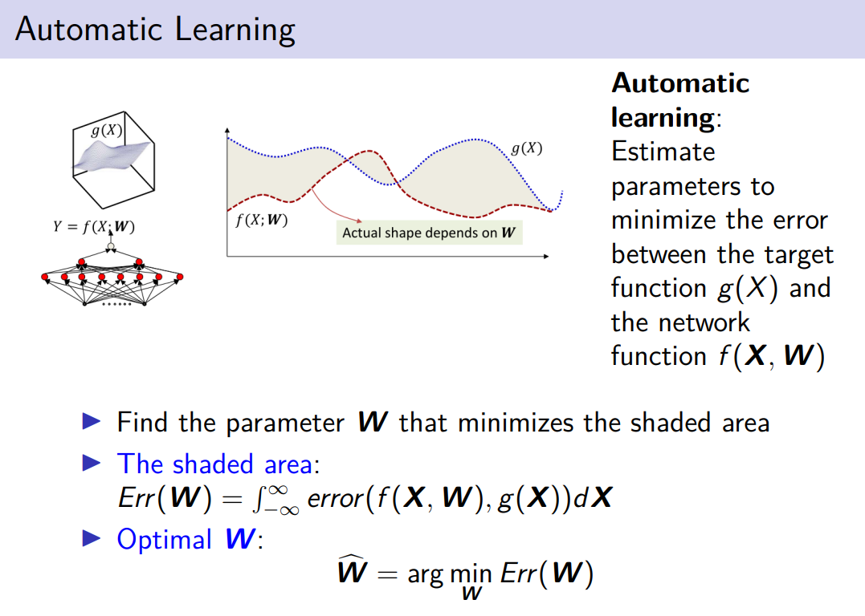

suppose we know the desired function g(x)
and we have our network that given an assignment for any input X output something that have to be compared ong g(x)

how accurate is out network: the bigger the shaded area the more inaccurate is the function f
we need the W that makes the shaded are as small as possible

shaded area is the integral of the given measure of the error computed on the desired outcome and the current outcome

the optimal W is the argument that minimized Err(W) it is called Ŵ (hat W)

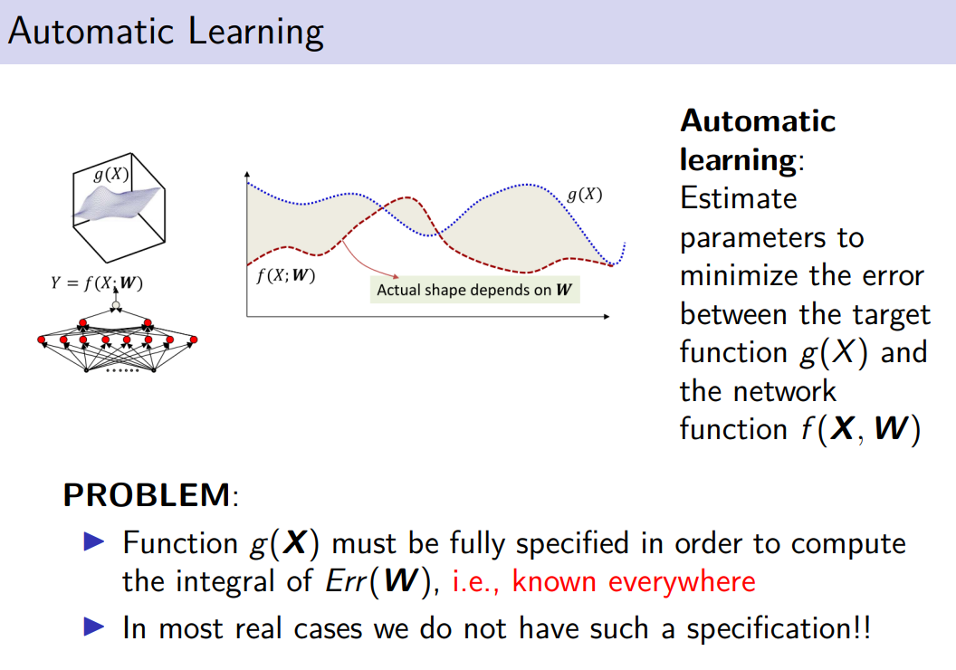
problem: g(X) is usually not known. We can so not computer Err(W) perfectly because g is ungiven.

But we can do an approximation of g by sampling

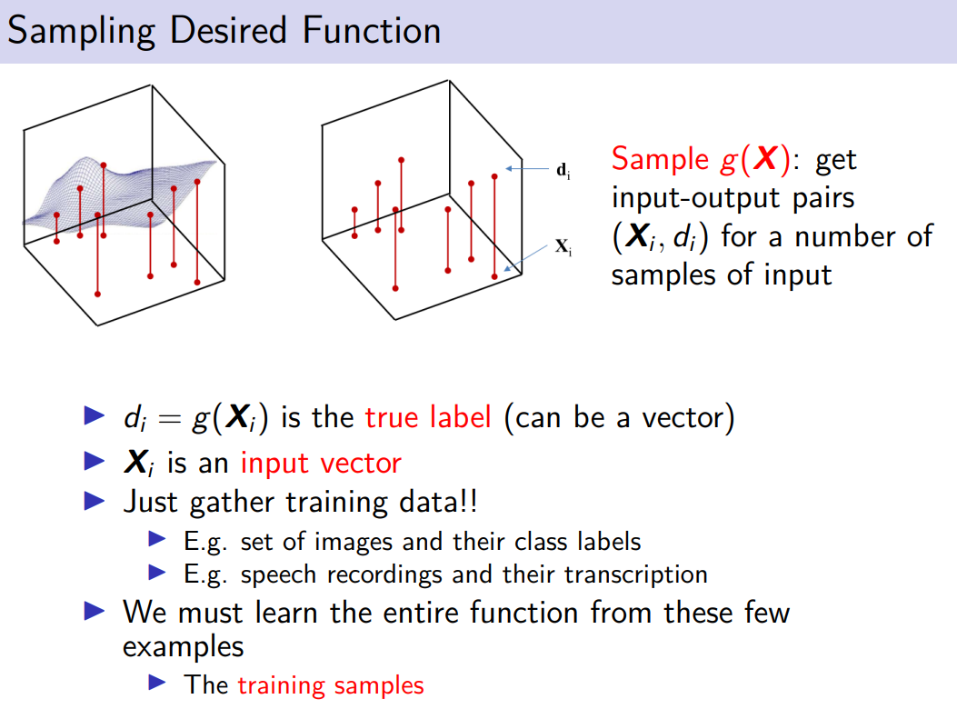

we are sampling some points over the function g

d_{i} is the output of the function g

we know some examples of input output and we would like to estimate and consideredt this sample as a proxi to estimate the function g. We do not have g but we have some points, you generalize to find the potential g

This mean that our criteria is not anymore the one of find W that minimize the error, we will minizme something different

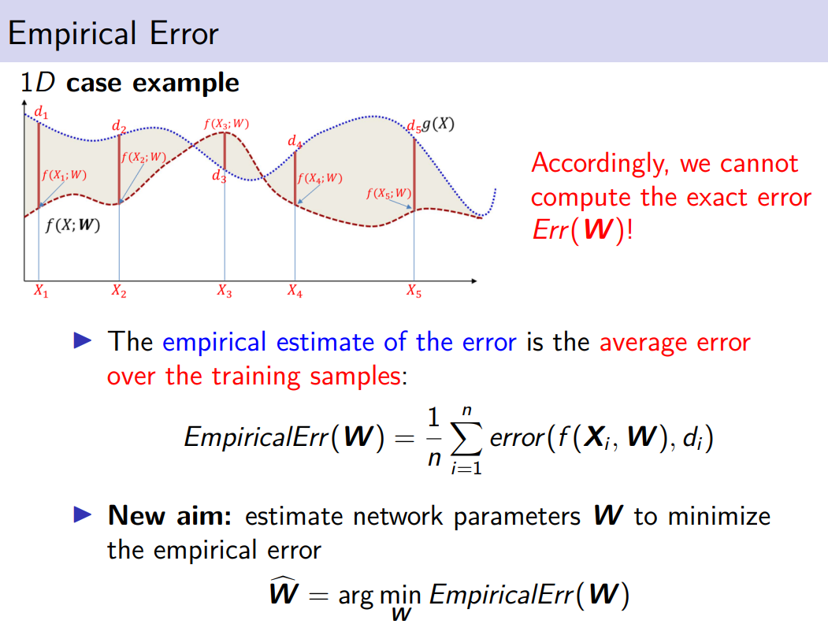
minimize the empirical error, aka the average error on the training sample

so now our optimal weights (W^) are those that minimize the empirical error

problem: we make an assumption that might not working. We have some samples and we know the true label, what about the other that we don’t know the label? can we say something about that?

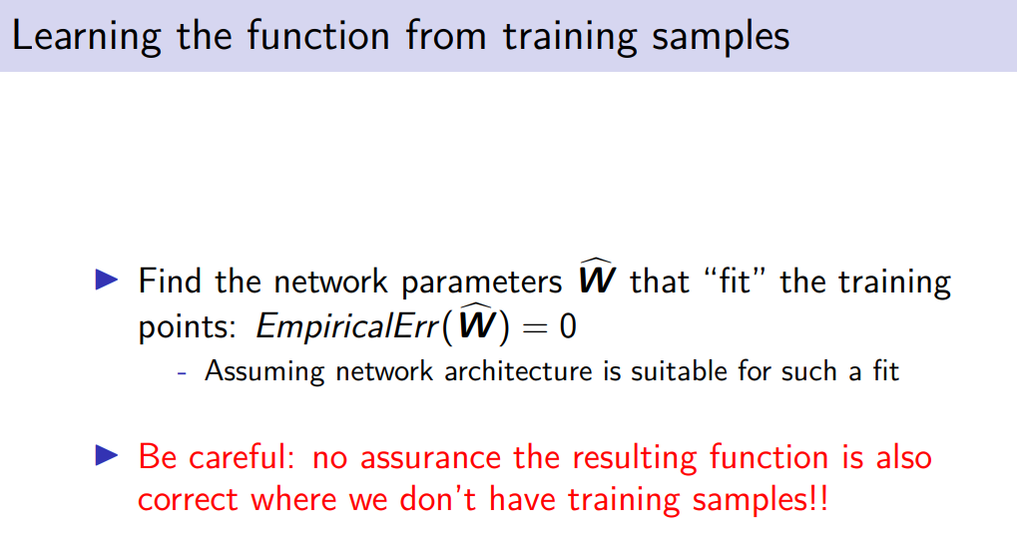

even in the case of EmpiricalErr(W^) is equal to 0. We can not say even in this case anything about the samples that we don’t have in the training samples. This is a problem of generalization

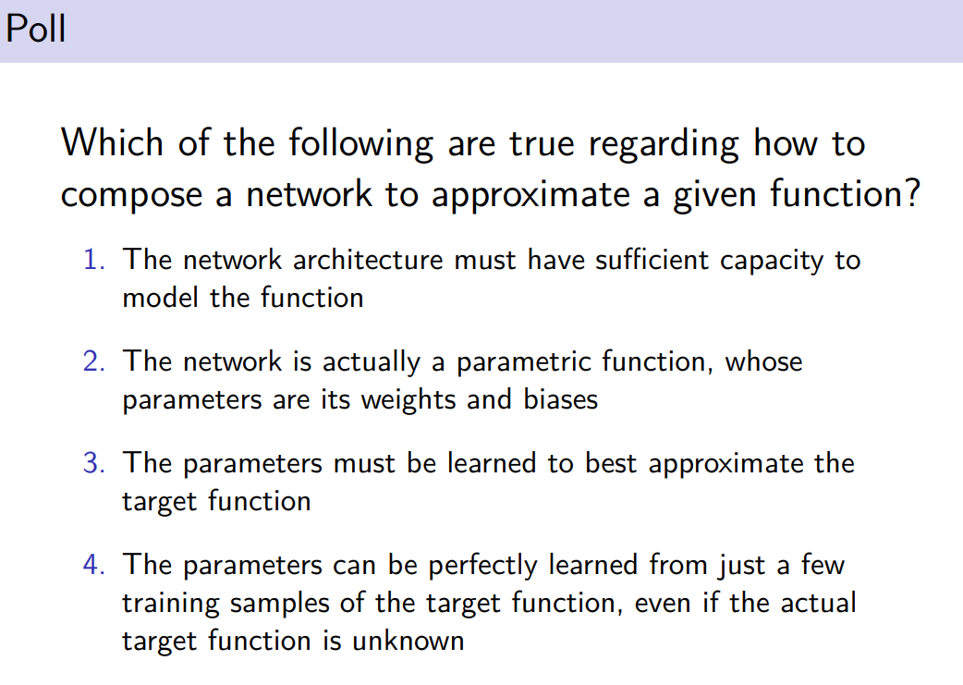

correct: 1-2-3

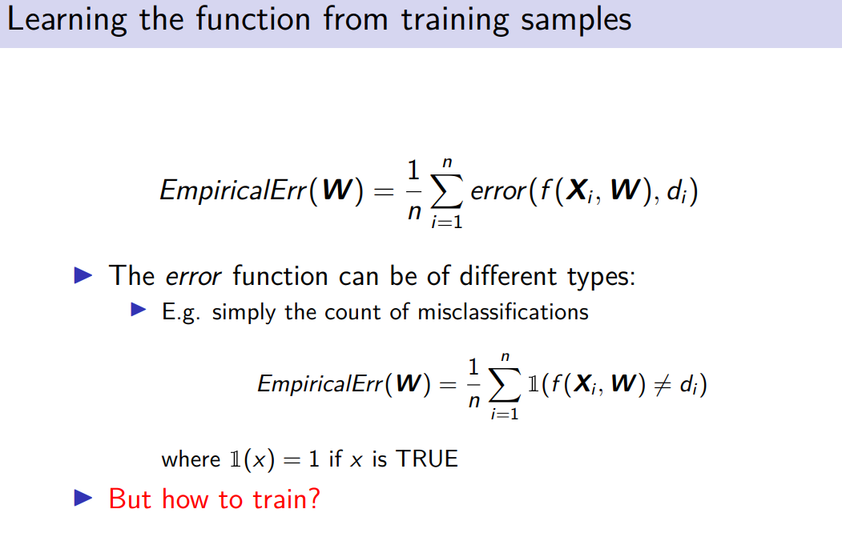

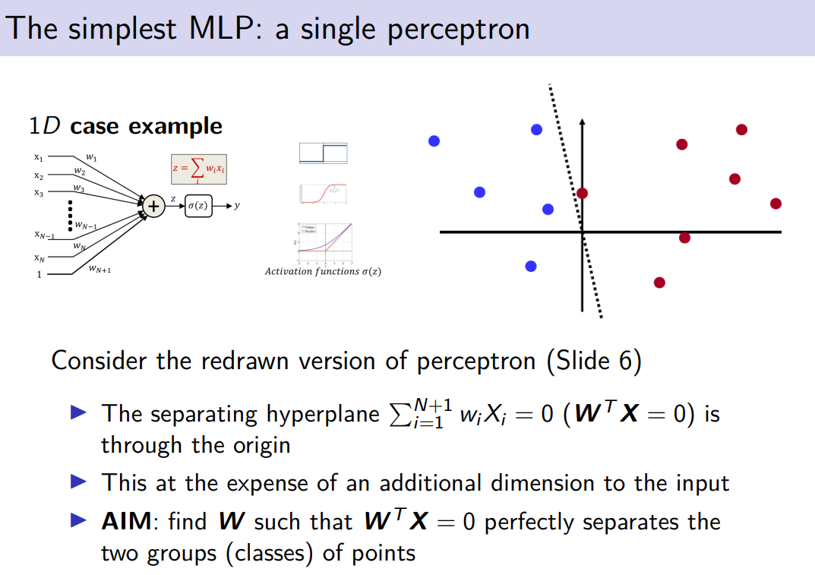
how effeclty we get to the hyperplane

we use same notation used so far

W have all the weights of perceptron + an additional weight

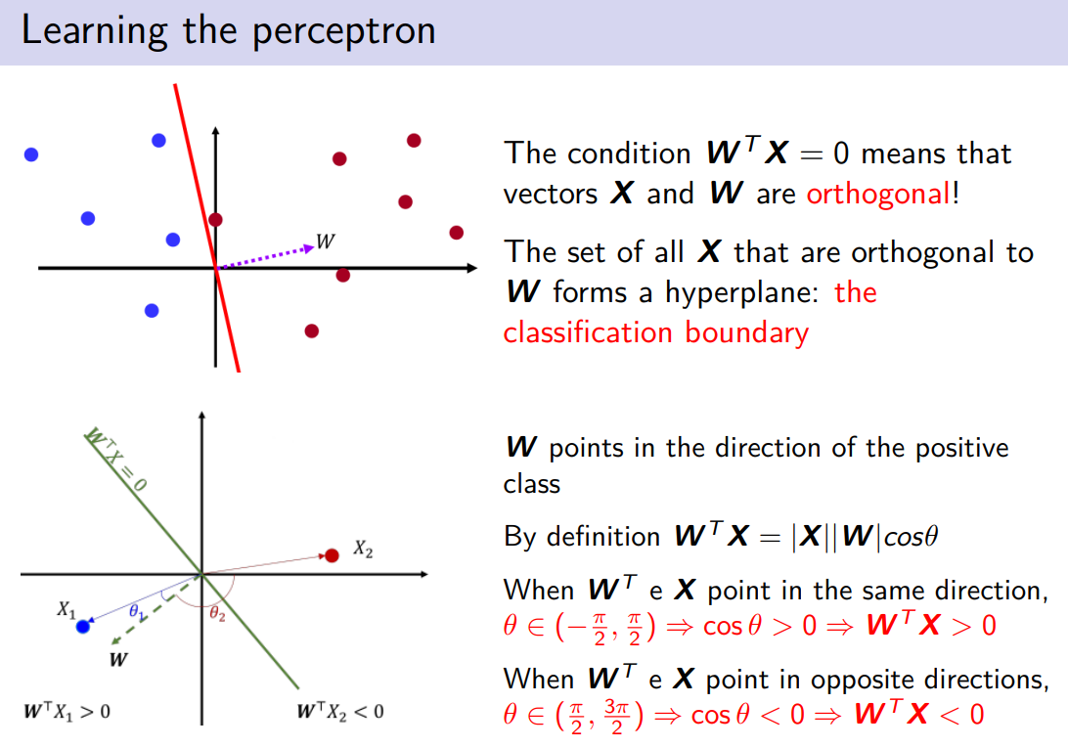
the general definition: the inner production can be defined as |X| |W| cos θ if they are orthogonal the cosine is 0.

All the points are orthogonal to W.

W is orthogonal to the hyperpleame, and it points on the positive region

W is a veectoro horothonsl to the hyperplane, and W points to the positive region

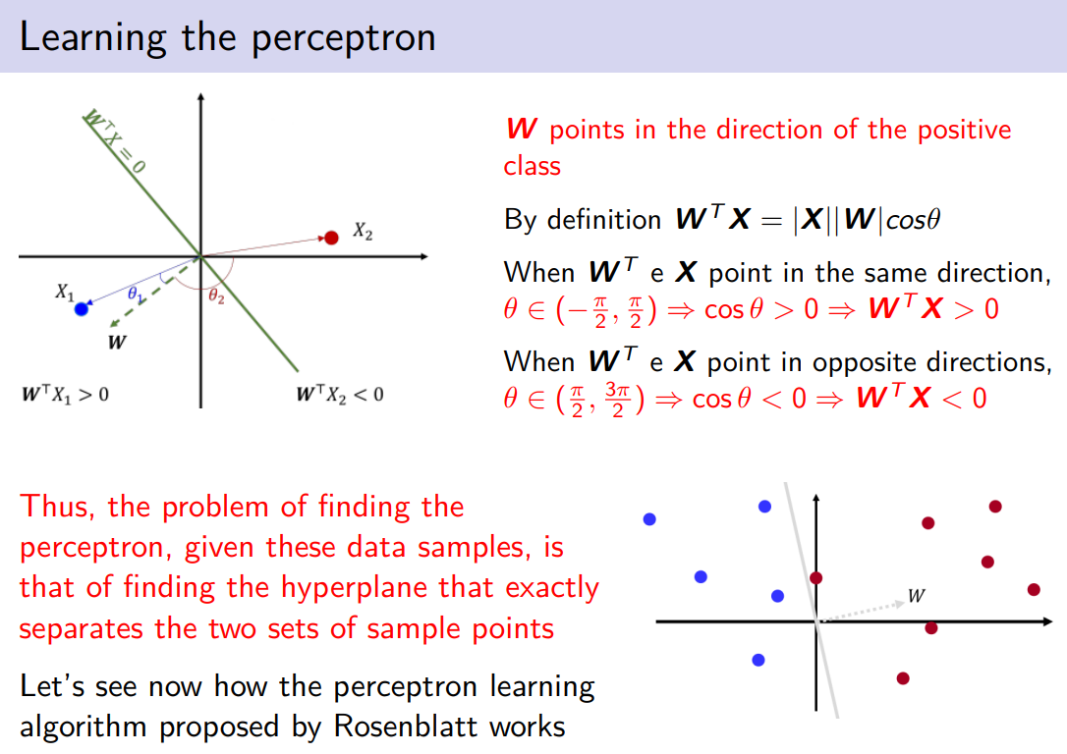

problem of perceptron: given all the data sample, at each time rotate the hyplerane so that is correctly classified

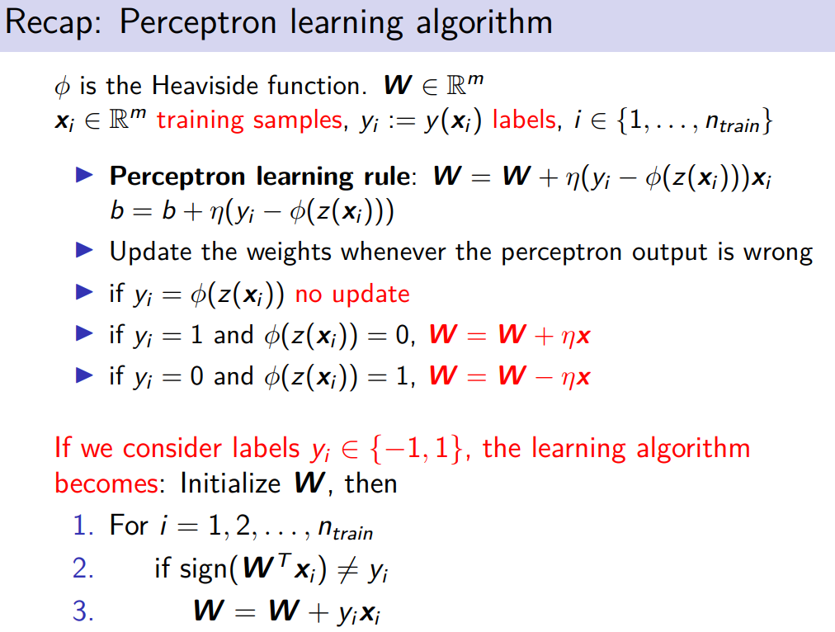

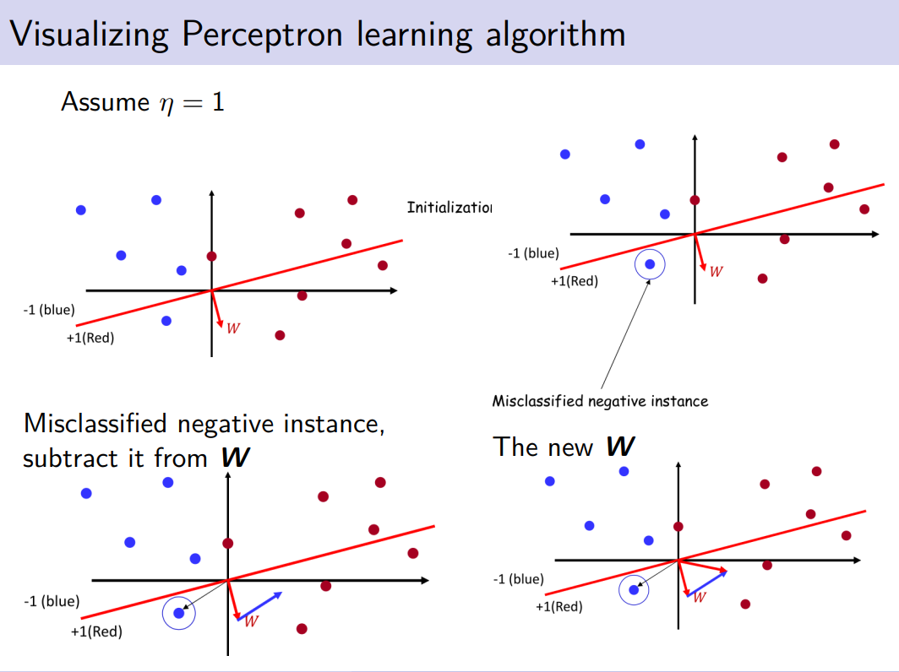

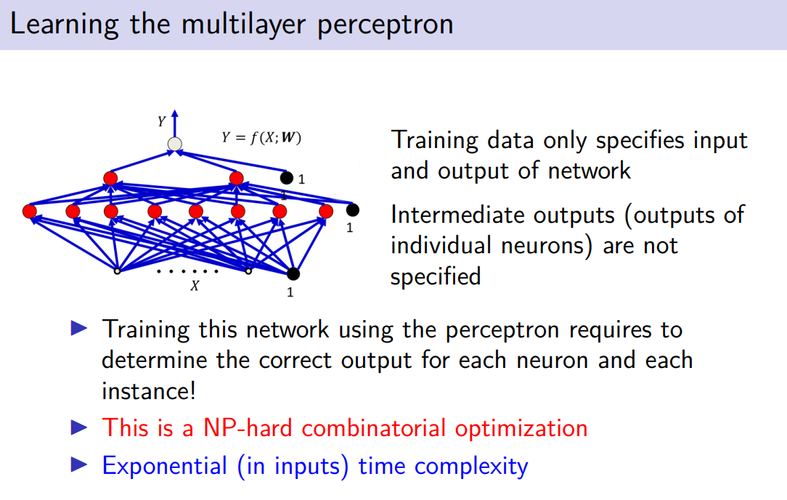
problem: need to know the correct output for that neuron in each instance
we know the input and the output but we don’t know the idden neuron output

for any input instance we java to get the output for any neuron, it is very complicated to do

even in case we would have that we need to some extend work and refine any individual network. It should continue to the overall outcome. Exponential time complexity

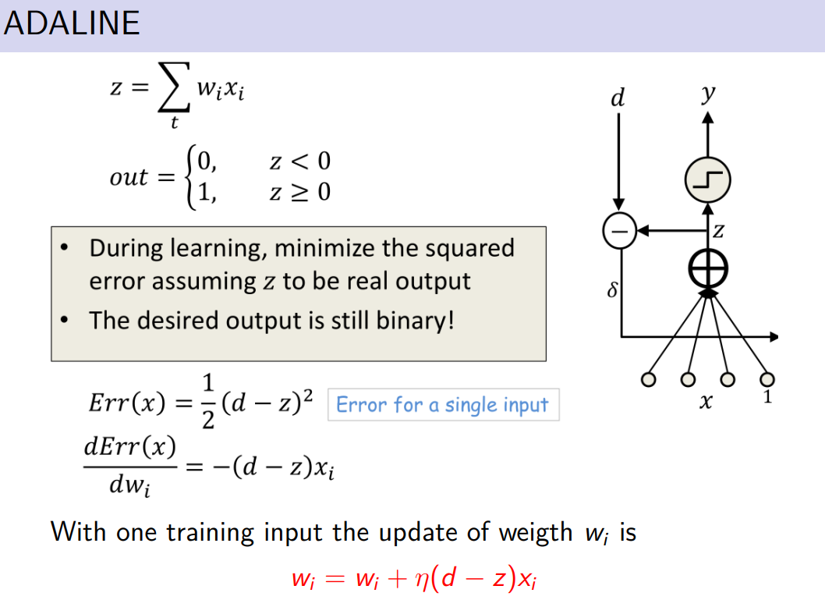

the difference is that the output is compared before any actiation function is applied

how to compute the update, we compute in order to minimize it the first derivative and set to 0

we considerd the derivative of the error fucntion.
add x_{i} because if you take the deriviative of z you get w_{i}x_{i} the derviative is x_{i}
all the other terms go to 0
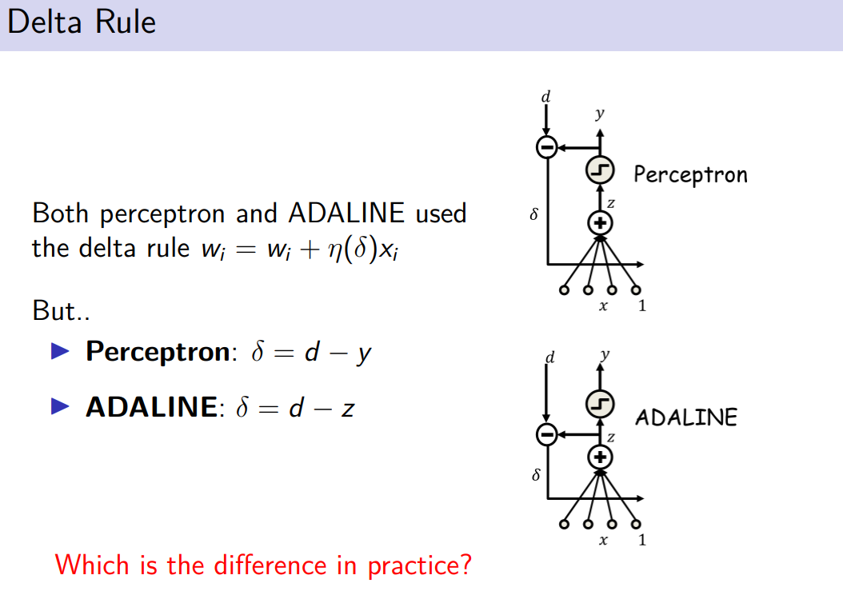

the difference is in practice if you have 2 inputs that leads the neuron to fire. In perceptron z overcome the treshold and so the neuron ouput1
if you have z slights bigger then 0. it will fire, also a neuron very big still fire, but they are the same for the perceptron

if you use z before the threshold, in both input the neruon will fire, but in the first case is very close to 0 while the second is very large. For the percetorn they are the same, for adaline no

perceptron will lose some information

